**EXERCISE -2**

**WRITE A C PROGRAM TO FIND ODD OR EVEN FROM THE GIVEN SET NUMBERS**

**AIM:** To find and separate odd and even numbers from a given list. **ALGORITHM:**

1: Start

2: Input number of elements

3: Input elements into an array

4: For each number, check if divisible by 2

5: If yes, it's even; else odd

6: Display all odd and even numbers

7: End

**PROGRAM:**

#include <stdio.h>

int main() {

int n, num;

printf("How many numbers do you want to check? ");

scanf("%d", &n);

for (int i = 0; i < n; i++) {

printf("Enter number %d: ", i + 1);

scanf("%d", &num);

if (num % 2 == 0)

printf("%d is Even\n", num);

else

printf("%d is Odd\n", num);

}

return 0;

}

**INPUT AND OUTPUT:**

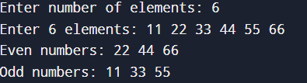

**RESULT:** Odd and even numbers identified successfully**.**